**Sequence Diagram for NGO/SSI Management :**

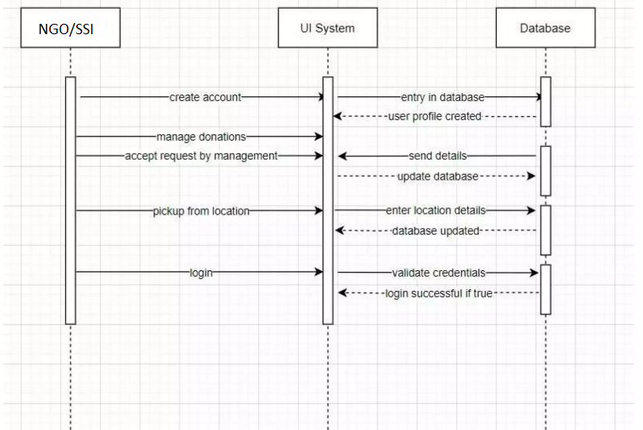

**Sequence Diagram for User(Doner) :**

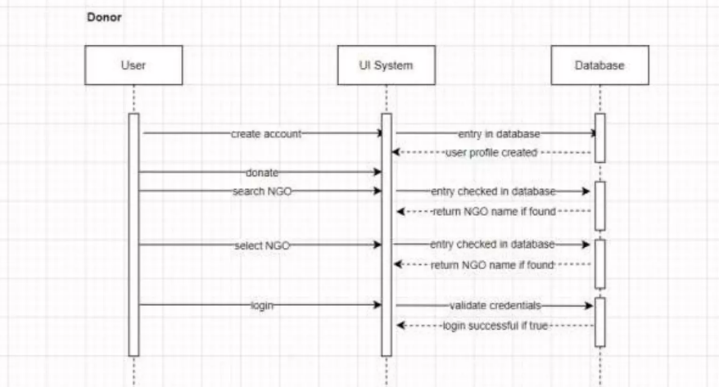

**Activity Diagram For NGO/SSI :**

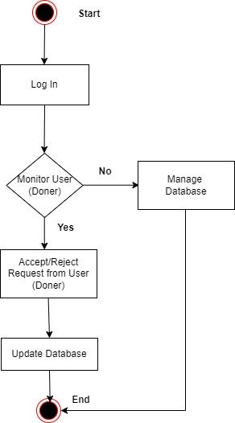

**Activity Diagram For User (Doner) :**

